**Array & string destructuring**

Array destructuing is a type of assignment destructuring which is used to **destructurise** the array to its elements and **assign** these elements to a bunch of variables **in** **respectively**.

**Syntax:**

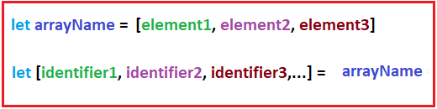

**Where:**

* Identifier1 = arrayname[0]
* Identifier2 = arrayname[1]
* Identifier3 = arrayname[2]

**Example 1:**

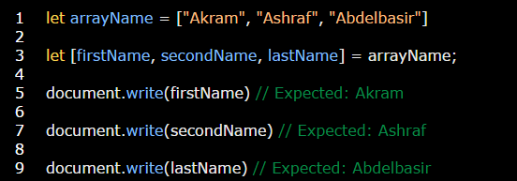

**Example 2:** you can also use string data type with split method instead of array.

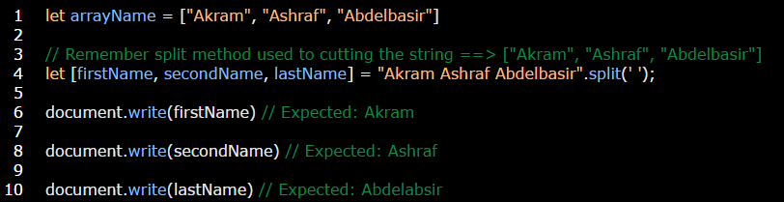

**Note:** you can ignore elements by using commas.

**Example:**

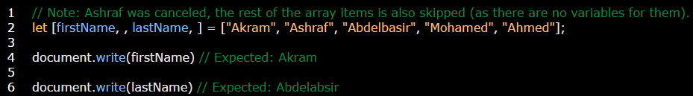

**Note:** you can use **…variable** to get rest values without variables, in this case **…variable** will treated as a *separated array.*

**Example:**

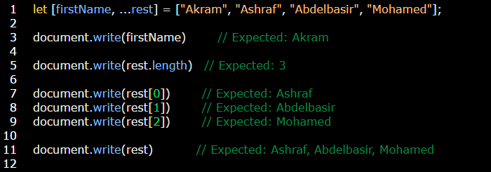

**Note:** destructuing can also occurs in strings not only arrays and objects.

**Example:**

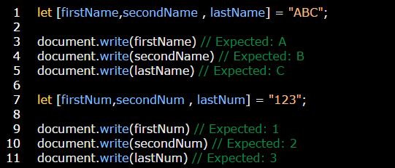

**Note:** If there are fewer values in the array than variables in the assignment, there will be no error. Absent values are considered undefined:

**Example:**

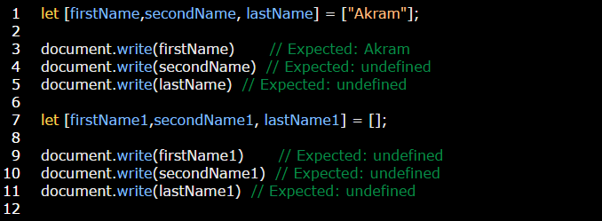

**Note:** we can determine a “default” value to replace the missing one, by using **=** operator.

**Example:**

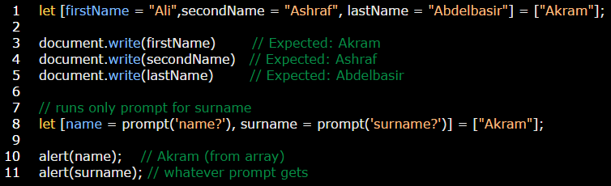

**Note:** we can swap values of variables.

**Example:**

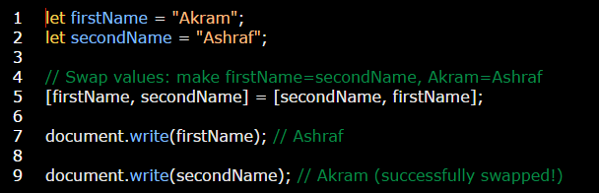

**Note:** you can use [Object.entries(objectName)](../object/object%20method/Object.entries(obj).docx) method (which is used to convert object to two dimensional array) with for of statement loop to make looping on destructuring.

**Example:**

